1.Rank employees by their total sales

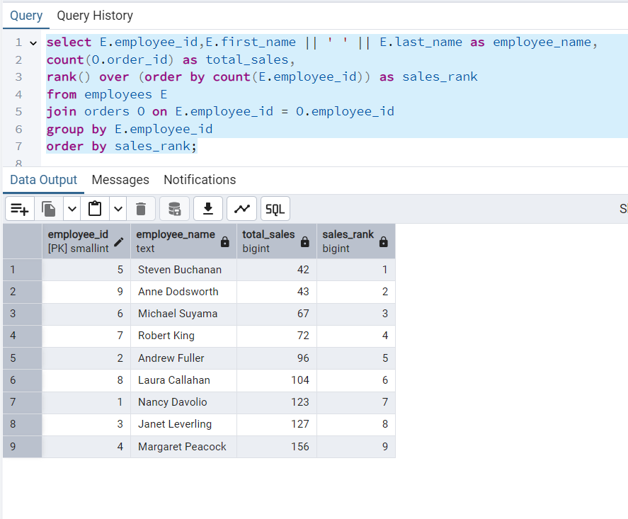

2. Compare current order's freight with previous and next order for each customer. Use lead(freight) and lag(freight).

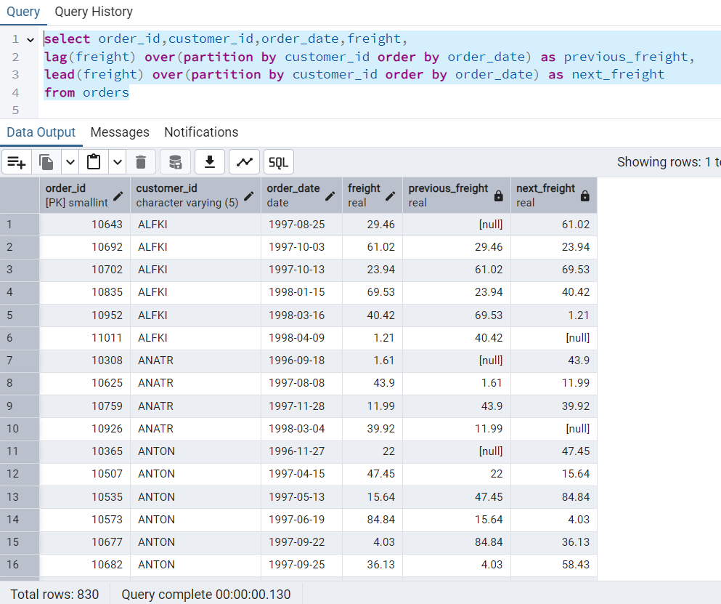

3. Show products and their price categories, product count in each category, avg price

